**INTRODUCATION OF SMART PARKING**

Smart parking is a modern and innovative approach to managing parking spaces in urban and suburban areas efficiently. It leverages technology and data-driven solutions to address the challenges associated with finding and using parking spaces in crowded and congested areas. The primary goal of smart parking is to enhance the overall parking experience for both drivers and parking lot operators, while also promoting sustainability and reducing traffic congestion.

Key components and features of smart parking systems include:

1. Sensors and IoT Technology: Smart parking systems use various sensors, such as ultrasonic, magnetic, or cameras, to detect the availability of parking spaces in real time. These sensors are connected through the Internet of Things (IoT) to provide up-to-the-minute data on parking occupancy.
2. Mobile Apps and Web Platforms: Users can access information about available parking spaces through dedicated mobile apps and web platforms. These applications provide real-time updates on parking availability, location, pricing, and even reservations.
3. Data Analytics: Smart parking systems collect and analyze data on parking space usage, helping operators make informed decisions to optimize parking lots and pricing strategies. This data can also be used for urban planning and traffic management.
4. Payment and Reservation Systems: Users can reserve parking spaces in advance or pay for parking through mobile apps or automated payment kiosks, eliminating the need for physical tickets or cash transactions.
5. Reduced Search Time: By providing real-time information on available parking spaces, smart parking systems significantly reduce the time and frustration associated with searching for a parking spot. This, in turn, reduces traffic congestion and fuel consumption.
6. Improved Revenue Generation: Parking operators can optimize their revenue streams by adjusting pricing dynamically based on demand. They can also minimize revenue loss due to unauthorized parking.
7. Sustainability: Smart parking systems contribute to sustainability efforts by reducing the environmental impact of parking. Drivers spend less time idling and circling in search of parking spots, leading to reduced emissions.
8. Integration with Navigation Systems: Some smart parking solutions can integrate with navigation apps, directing drivers to available parking spaces and providing estimated walking distances to their destinations.
9. Security and Safety: Enhanced surveillance and security features, such as cameras and emergency call buttons, can improve safety in parking facilities.
10. Scalability and Future-Proofing: Smart parking systems are often designed to be scalable and adaptable to future technological advancements, ensuring their longevity and relevance.

Smart parking is being increasingly adopted in urban areas to address the growing challenges of congestion, limited parking spaces, and the need for more efficient use of urban infrastructure. It not only benefits drivers by making their parking experience more convenient but also supports city planning efforts to create more sustainable and livable environments.

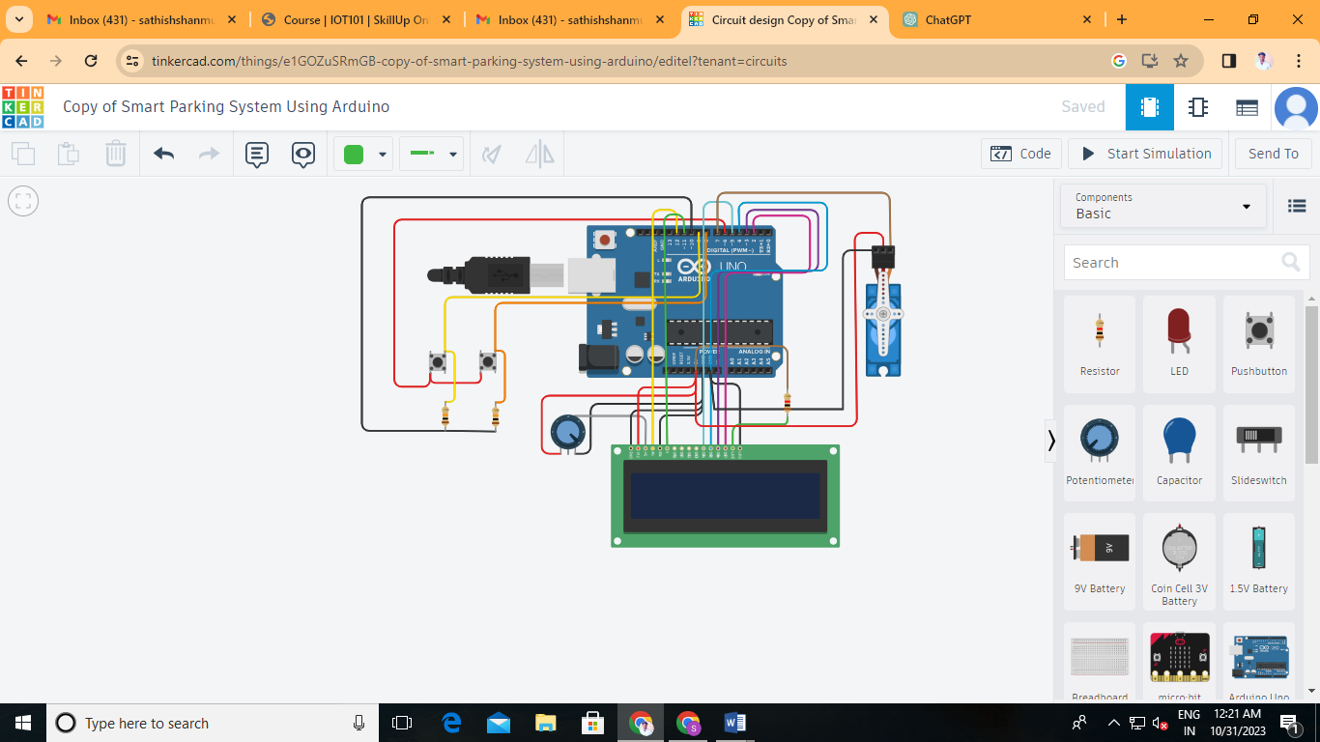

PROJECT LINK:

<https://www.tinkercad.com/things/e1GOZuSRmGB-copy-of-smart-parking-system-using-arduino/editel?tenant=circuits>

PROGRAM:

#include <Servo.h>

#include<LiquidCrystal.h>

LiquidCrystal lcd(12,11,5,4,3,2);//connected to RS,EN,D4,D5,D6,D7 of LCD display respectively

Servo myservo; // create servo object to control a servo

#define ServoM 7 //Connected to the servo motor.

#define Exit 9 //Pin connected to the EXIT sensor.

#define In 8 //Pin connected to the IN sensor.

#define Pwr 6 //Extra power pin for sensors(Don't connect servo's power to this!)

#define Gnd 10 //Extra groung pin for sensors(Don't connect servo's power to this!)

#define BarLow 90 //Low position of the barrier.

#define BarUp 177 //Up position of the barrier.

#define CAPACITY 7 //Capacity of the parking lot.

void setup(){

myservo.attach(ServoM); // attaches the servo.

lcd.begin(16,2);

lcd.print("Space left for");

pinMode(Gnd, OUTPUT);

pinMode(Pwr, OUTPUT);

pinMode(Exit, INPUT); // set "EXIT" sensor pin to input

pinMode(In, INPUT); // set "IN" sensor pin to input

digitalWrite(Gnd, LOW);

digitalWrite(Pwr, HIGH);

myservo.write(BarLow); //Barrier in the low position

// delay(1000);

}

int Available= 7; // Number of places available.

//================================================================

void loop(){

if (Available == 1){

lcd.clear();

lcd.setCursor(1,0);

lcd.print("Space left for");

lcd.setCursor(0,1);

lcd.print(Available);

lcd.print(" car");

}else{

if (Available >= 1){

lcd.clear();

lcd.setCursor(1,0);

lcd.print("Space left for");

lcd.setCursor(0,1);

lcd.print(Available);

lcd.print(" cars");

}else{

lcd.clear();

lcd.setCursor(1,0);

lcd.print("Sorry!");

lcd.setCursor(0,1);

lcd.print("No place left!");

}

}

if(digitalRead(In)==1)

{

if(Available != 0){

Available--;

myservo.write(BarUp);

delay(3000);

myservo.write(BarLow);

}

}

if(digitalRead(Exit)==1)

{

if(Available != CAPACITY){

Available++;

myservo.write(BarUp);

delay(3000);

myservo.write(BarLow);

}

}

delay(20);

}

DIAGRAM:

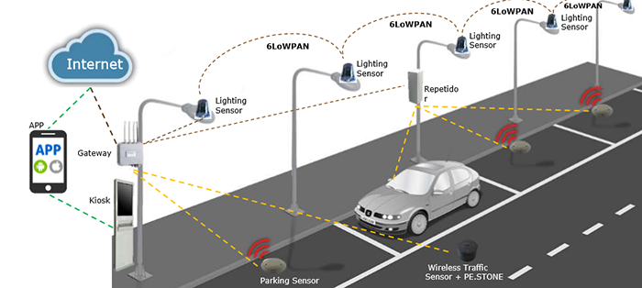

BLOCK DIAGRAM:

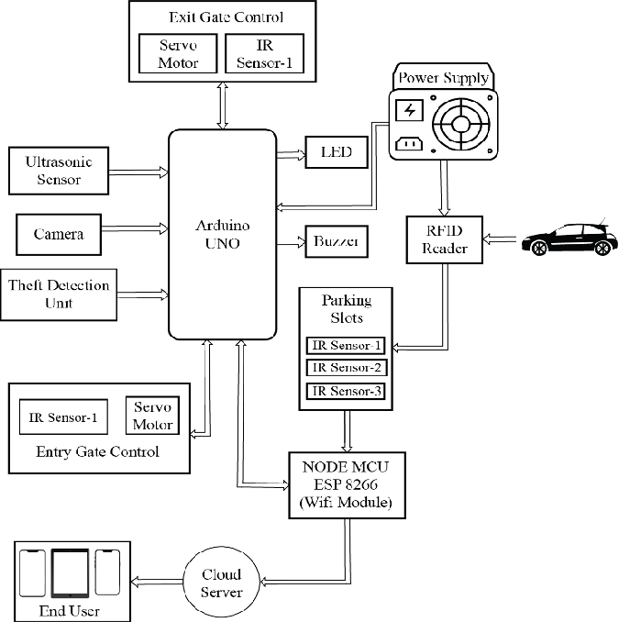

COMPONENT:



OUTPUT:

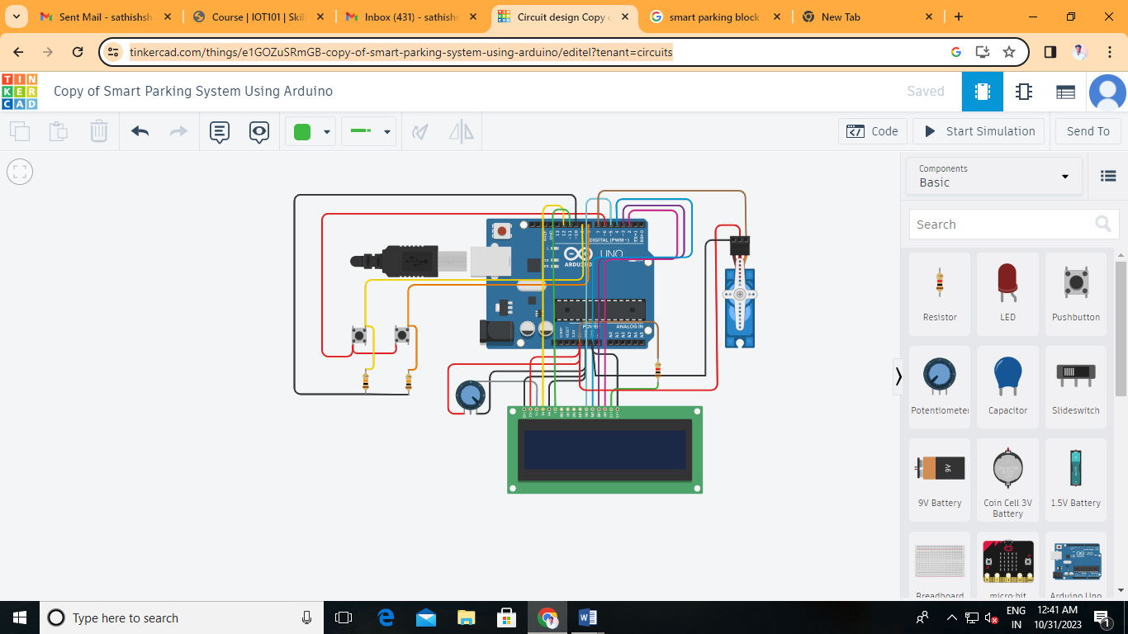

ADVANTAGE OF SMART PARKING :

Smart parking systems offer numerous advantages for both drivers and parking facility operators. Here are some of the key benefits of smart parking:

1. **Reduced Search Time:** One of the most significant advantages of smart parking is the reduction in the time it takes for drivers to find available parking spaces. This not only saves time but also reduces frustration and stress.
2. **Improved Efficiency:** Smart parking systems optimize the utilization of parking spaces, ensuring that they are used more effectively. This can lead to increased revenue for parking facility operators.
3. **Real-Time Information:** Drivers can access real-time information about available parking spaces through mobile apps or signage, making it easier for them to make informed decisions.
4. **Reservation and Prepayment:** Some smart parking systems allow drivers to reserve and prepay for parking spaces, ensuring that a spot is available upon arrival and streamlining the payment process.
5. **Reduced Traffic Congestion:** By helping drivers find parking quickly, smart parking systems contribute to reduced traffic congestion and decreased fuel consumption, leading to a more efficient transportation system.
6. **Cost Savings:** Smart parking can lead to cost savings for drivers through reduced fuel consumption and the avoidance of fines for parking violations.
7. **Enhanced Security:** Many smart parking facilities are equipped with surveillance cameras and proper lighting, enhancing the security of vehicles and pedestrians.
8. **Data and Analytics:** Smart parking systems collect data on parking utilization, which can be analyzed to optimize parking management and city planning. This data can also help with predictive maintenance.
9. **Eco-Friendly Benefits:** Smart parking systems help reduce emissions by reducing the time spent idling and searching for parking. They can also encourage the use of alternative transportation methods.
10. **Increased Revenue for Operators:** Parking facility operators can maximize their revenue by efficiently filling available parking spaces and using dynamic pricing to adjust rates based on demand.

TINKERECAD LINK :

<https://www.tinkercad.com/things/9ZiI2KjU1n3-smart-parking-system-using-arduino>

CONCLUSION:

Smart parking solutions that utilize machine learning offer significant advantages in terms of efficiency, convenience, and environmental sustainability. By analyzing vast amounts of data, these systems can optimize parking management, enhance the overall parking experience, and contribute to more sustainable and connected urban environments.

In conclusion, the integration of machine learning in smart parking has the potential to revolutionize the way we approach parking, leading to reduced search times, cost savings, improved traffic flow, increased revenue for operators, enhanced security, and a more environmentally friendly approach to urban mobility. These benefits make smart parking systems driven by machine learning a valuable component of smart city initiatives, offering a glimpse into the future of urban transportation and parking management.